

**“The Great Moderation, the Great Panic and the Great Contraction”**

Speech given by

Charles Bean, Deputy Governor for Monetary Policy and Member of the Monetary Policy Committee, Bank of England

Given at the Schumpeter Lecture, Annual Congress of the European Economic Association, Barcelona

25 August 2009

I am grateful for the assistance of Adrian Penalver. The views expressed are those of the author and do not necessarily reflect those of either the Bank of England or the Monetary Policy Committee.

1

All speeches are available online at [www.bankofengland.co.uk/publications/Pages/speeches/default.aspx](http://www.bankofengland.co.uk/publications/Pages/speeches/default.aspx)

Summary

Charles Bean, the Bank of England’s Deputy Governor, Monetary Policy, was invited to deliver the Schumpeter lecture at the Annual Congress of the European Economic Association. *The Great Moderation, the Great Panic and the Great Contraction*, looks back at the causes of the financial crisis and subsequent recession. He argues that much of what went wrong can be analysed using standard economic tools.

The Great Moderation was a period of unusually stable macroeconomic activity in advanced economies. This was partly thanks to good luck, including the integration of emerging market countries into the global economy, and partly a dividend from structural economic changes and better policy frameworks. The longer this stability persisted, the more markets became convinced of its permanence and risk premia became extremely low. Real short and long term interest rates were also low due to a combination of loose monetary policy, particularly in the US, and strong savings rates in a number of surplus countries.

Low interest rates and low apparent risk created strong incentives for financial institutions to become highly geared. Unfortunately much of this leverage occurred off-balance sheet in order to avoid on-balance sheet capital charges. The innovative financial instruments developed to achieve this were highly complex. This complexity did not seem to matter when markets were steady and defaults low but was fatal once conditions deteriorated, as it became impossible to understand and price these instruments objectively. Leveraged institutions were trapped; as their assets sank in value and funding dried up, buyers became wary – a classic lemons problem. As losses moved inexorably towards institutions at the heart of the financial system, the complexity of the inter-bank network created enormous uncertainty about the extent of counterparty risk.

Uncertainties in the financial system were transmitted to the real economy after the collapse of Lehman Brothers as expectations of future credit tightening, higher precautionary savings and the postponement of investment took a sudden and widespread toll on global demand.

This made the task of deleveraging in the financial system even more difficult and the tightening of credit more severe. Central banks responded aggressively with sharp cuts in policy rates. To affect the yield curve over the medium run, central banks have made explicit commitments to keep rates low for a significant period of time or engaged in purchases of financial assets. Policy makers are also considering the benefits of developing additional macroprudential instruments which can be used to respond to rapid credit growth and rising asset prices. These new instruments should directly target the incentives to extend excessive credit. But there are a number of practical questions to answer before they can be implemented.

Charles Bean concludes that it is a mistake to look for a single culprit. Just as in Agatha Christie’s *Murder on the Orient Express*, those with different motives but similar objectives can all contribute to the same outcome. The economics profession was one of those culprits and there are lessons for the discipline. It could incorporate psychology or behavioural economics into the study of financial markets but this may be unnecessary since much of the story can be explained using standard microeconomics. Economists should take more notice of history and not treat crises as pathologies that happen in other times or in other places but as a central feature of free-market economies that models should aspire to explain. Finally, macroeconomists have to learn how to put credit markets into their models in a meaningful way and which enable us to model shocks originating in the financial sector rather than just as an amplification mechanism.

###### The Great Moderation, the Great Panic and the Great Contraction

The past twenty-four months have been tumultuous for the global economy, for economic policy makers and, indeed, for the discipline of economics. Following a long period of unusually good economic performance, characterised by relatively steady growth and low and stable inflation in the advanced economies and rapid growth and development in key emerging market economies, we have seen the eruption of a systemic financial crisis of quite unusual intensity and international reach. The nearest precedent is probably the widespread closing of international capital markets on the eve of the First World War. And associated with that, we have seen the sharpest internationally synchronised slowdown in growth in the post-war period, together with an unprecedented contraction in world trade.

To the public at large our present troubles are the fault of: whiz-kid financiers, who created financial instruments that even they didn’t properly understand; greedy bankers, who pursued profit and personal reward without regard to risk or common sense; somnolent supervisors, who failed to adequately regulate and restrain those bankers; and negligent central bankers, who allowed an explosion in liquidity, credit and asset prices that supported the whole rotten edifice. And all the while, the culprits were cheered on by an economics profession that was over-enamoured of theoretical models, blind to the lessons of history and subject to a severe case of ‘group think’. Wasn’t it blindingly obvious that the whole house of cards would come crashing down at some point?

As one of those involved in responding to the crisis – and some might charge also a bit part in creating the conditions for it – I want to look this evening at how we got here. But rather than giving a blow-by-blow account of events, I want instead to focus on what I see as the key underlying economic forces. How could what appeared initially to be little more than an

over-extension of loans to a high-risk subset of US households end up generating total financial sector losses in the advanced economies currently estimated by the IMF to be in the region of $4.1 trillion and an output gap that is expected to reach nearly 6% of GDP in 2010? And while there were a few Wise Owls1 who saw trouble coming, why did most of the profession fail to spot the dangers? Is that because we were locked into an inappropriate

1 Most notably Nouriel Roubini, Bob Shiller and Bill White and others at the BIS.

paradigm? If so, is the time ripe for a Schumpeterian ‘gale of creative destruction’ in the subject?

*The credit boom*

Let me start by recalling a few facts regarding the credit boom that preceded the crisis. During the decade preceding the crisis there was a substantial increase in the ratio of household and business debt to GDP in a number of advanced economies, particularly the United States, the United Kingdom and Spain; see the left-hand panel of Fig. 1. A striking feature of this period was also the increased use of the credit markets by the financial sector to fund its activities, rather than relying on the traditional medium of deposits; that is illustrated in the right-hand panel for the United States.

This build up in debt accompanied a wave of financial innovation. There was a marked expansion in the issuance of asset-backed securities: bundles of residential and commercial mortgages, other consumer credit, and of loans to businesses that were sold on by the loan originator, thus shifting the associated risks. And a new class of asset in the shape of Collateralised Debt Obligations (CDOs) was created, which facilitated a further layer of restructuring and redistribution of the risks in an asset-backed security. The extent to which loans were moved off balance sheet through these means is shown in Fig. 2 (left-hand panel). Finally, we saw a veritable explosion in the issuance of Credit Default Swaps (CDSs), which allowed investors to hedge themselves against a wider range of default risks (right-hand panel).

The picture that emerges from this is one of a more complex process of financial intermediation, but one in which the innovation in contracts apparently allowed specific types of risks to be split out, traded and redistributed towards those in a better position to bear them. We thus seemed to be moving ever closer to an idealised Arrow-Debreu world of a full set of state-contingent securities. Moreover, it seemed natural to think that the increased dispersion of risk would make the financial system more, rather than less, stable, a view that was certainly held by the former Chairman of the US Federal Reserve, Alan Greenspan:

“These increasingly complex financial instruments have been especial contributors, particularly over the past couple of stressful years, to the development of a far more

flexible, efficient, and resilient financial system than existed just a quarter-century ago.” (Greenspan, 2002).

Accompanying this expansion in credit, there was also a rise in certain asset prices, particularly that of housing, in those countries where credit rose most sharply (see Fig. 3). But significantly, that explosion in credit was not associated with a marked expansion either in the demand for goods and services, or in consumer price inflation. It is also notable that the run-up in house prices in the United States was less marked than in the other Anglophone countries and Spain. In part, that may reflect a more elastic response in the construction of new houses in the United States.

The point to stress is that there was nothing self-evidently wrong with this expansion in balance sheets and the associated rise in asset prices. There is some evidence from developing economies that suggests that increased development in financial markets helps to foster growth and catch-up. And if financial innovation allows households to gain access to mortgage finance where they were previously unable to, one should expect that to lead to a rise in the real price of houses. But just as there is evidence that increased financial intermediation is often a Good Thing, so there is also evidence from numerous past credit/asset price boom-bust episodes that a juxtaposition of rapid credit expansion and sharp asset price increases is often a harbinger of a painful bust to come. So everything hinges on whether the underlying developments are sustainable or not. The mistake of (most of) the economics profession, along with many others, was a failure to see what was really going on beneath the surface and to understand how disruptively things could unwind. But, as I shall explain, I believe that the standard tools of economic analysis, far from being proved redundant, can shed useful light on what went wrong.

*Macroeconomic antecedents*

The proximate causes of the present crisis undoubtedly lie within the financial markets. But it is worth dwelling briefly on the macroeconomic environment in the years preceding the crisis, which was conducive to the formation of what proved to be an unsustainable credit bubble.

*The Great Moderation*

To begin with, this period was characterised by an unusually high degree of macroeconomic stability, with steady growth and low and stable inflation in most of the advanced economies; see for instance Fig. 4, which shows performance in the G5 countries before and after 19922. There are three broad explanations for this ‘Great Moderation’.

First, it could just have been a happy accident, if this was a period characterised by unusually small, or a benign sequence of, shocks. In particular, access to a cheap source of manufactured goods as result of the rapid development of China and other emerging market economies created a terms of trade gain for the advanced countries and a beneficial ‘tailwind’, which only mutated into a ‘headwind’ towards the end of the period as rapid global growth put upward pressure on oil and other commodity prices.

Second, changes in the structure of the economy could have meant that similar sized shocks had smaller macroeconomic effects. Candidate structural changes included the shift from manufacturing to services, tighter control of inventories leading to an attenuation of the inventory cycle, increased competition in product and labour markets, and innovation in financial markets that facilitated the greater spreading of risk and an enhanced ability to smooth spending in the face of shocks to income or wealth.

A final possibility is that better macroeconomic policies, including improved policy frameworks, had moved economies closer to the eponymous Taylor frontier which traces out the lowest achievable inflation volatility for a given volatility of the output gap. In particular, earlier periods were bedevilled by monetary policies that had failed to anchor inflation expectations. But the pursuit of inflation targets and similar stability-oriented monetary policies by independent central banks seemed to have been more successful in anchoring inflation expectations.

Now if the Great Moderation was down to ‘good luck’, then improved macroeconomic performance was more likely to be ephemeral. But if it was down to structural changes or better policy, there was more chance of it proving permanent. Moreover, if it was permanent,

2 The Great Moderation appears to have started rather earlier, in the mid-1980s, in the United States.

then part of the ‘dividend’ from this reduced macroeconomic volatility should be a greater willingness to take on risk.

As it happens, the academic literature has so far failed to provide a conclusive answer on the relative contributions of the various explanations3. But what matters is how market participants responded to these benign conditions. They are faced with what is, in essence, a complex signal-extraction problem. But whereas many such problems in economics involve learning about first moments of a distribution, this involves making inferences about higher moments. The longer such a period of low volatility lasts, the more reasonable it is to assume that it is permanent. But as tail events are necessarily rarely observed, there is always going to be a danger of underestimating tail risks.

Certainly it appears from measures of volatility implied from options prices for US equities

(VIX) and treasuries (MOVE) that the perceived risks in financial markets had shrunk to extremely low levels by 2006; see Fig. 5. There are two ways of rationalising this. One possibility is straightforward extrapolation into the future of the benign experience of the preceding few years. An alternative and complementary explanation is excessive faith in the ability of policy makers to maintain steady growth in the real economy. The Fed’s reluctance to use interest rates to lean against asset price booms coupled with a willingness to relax monetary policy aggressively in the wake of sharp asset price falls (Greenspan, 2002) may also have helped place a floor under expected asset prices (the ‘Greenspan Put’; see Miller, Weller and Zhang, 2002).

A tendency of people to underestimate future risks during periods of good economic performance seems to be a recurring theme in the history of financial markets. In part this seems to be a mixture of a willingness or desire to believe that the world has changed for the better, and moreover to find ways to rationalise that belief – in other words, “this time it’s different”. To that must be coupled a limited imagination – shared in this instance with regulators and central bankers – to see quite how badly things could go wrong. But when market participants can claim, as David Viniar, the Chief Financial Officer of Goldman

3 In part, that is because shocks are not measured directly, only their consequences; so what appears to be ‘good luck’, may reflect the beneficial influence of structural changes or better policy in ameliorating their impact; see Bernanke (2004). Other contributions to this literature include: Cogley and Sargent (2005), Sims and Zha (2006), and Stock and Watson (2003), who ascribe a sizeable portion of the improved performance to good luck; and Clarida, Gali and Gertler (2000) and Lubik and Schorfheide (2004), who put more weight on better policies.

Sachs, did in August 2007 that they “were seeing things that were 25-standard deviation moves, several days in a row” it is a sign that something must be badly wrong4. Wrong, that is, not with the world, but rather with market participants’ estimation of risk.

A particular feature of this underestimation of risk lay in the prevalent assumption that bad shocks were likely to be uncorrelated with each other. Thus the management of Northern Rock probably believed that if they were unable to roll over their short-term wholesale funding in the Asset-Backed Commercial Paper market, then they would always be able to find an alternative source of funds in the inter-bank market. But as it transpired, the same forces that led to a shutting down of the former in August 2007 also led to the closure of the latter at all but very short maturities. By the same token, many investors thought they had purchased relatively safe securities because there were insured against default by the monolines or through the purchase of CDS contracts. But that insurance proved worthless when large correlated losses occurred and the insurers proved to have insufficiently deep pockets. A systemic financial crisis is apt to generate dysfunctions in multiple markets simultaneously, making bad tail outcomes much more likely to occur than they appear when risks are treated as largely independent. And joint distributions with independence in the central mass but high correlation in the tails are likely to be extremely hard to model and calibrate.

*Monetary policy*

Other macroeconomic features also probably contributed to the growth in credit leading up to the crisis. In particular, according to some monetary policy was too loose over this period, especially in the United States (see Taylor, 2007). Fig. 6 shows the difference between the policy rate and benchmark estimates of an ‘appropriate’ policy rate derived from a Taylor rule. Notwithstanding the usual caveats about the construction of such benchmarks, the very low level of the Federal Funds rate relative to the Taylor rule during 2001-5 is striking. Of course, the FOMC held rates this low for a reason – they were concerned about entering a Japanese-style deflation and in order to mitigate that risk committed to holding the policy rate at a low level for a sustained period so as to pull down longer-term market interest rates.

4 Dowd, Cotter, Humphrey and Woods (2008) calculate that, with a normal distribution, a 25-sigma daily event should occur about once in every 1.31 x 10135 years; to put this in context, the universe is estimated to be just 12- 14 billion years old!

There is, though, little to suggest that policy rates were noticeably out of line in the euro area and the United Kingdom. Credit was nevertheless growing rapidly, as documented earlier in Fig. 1. Despite generally low and stable inflation, that led some – most notably Bill White and colleagues at the Bank for International Settlements (Borio and White, 2003; White 2006)

– to argue that the credit/asset-price boom was storing up trouble for the future. Accordingly, they argued that central banks should actively ‘lean against the wind’ to mitigate these risks, even though inflation objectives did not appear to be under threat. Others, including the present and former Chairmen of the Federal Reserve, took the view that diagnosing a misaligned asset price was only possible in retrospect and that only a large increase in policy rates could stop such a boom, which risked creating exactly the shock to the real economy that one wanted to avoid (see Bean, 2003, and the references therein). I shall return to this issue at the end of this lecture.

*Global imbalances*

Another feature of potential importance is the counterintuitive pattern of international capital flows. The rapid development and integration into the global market economy of China, India, Brazil and other emerging market economies could have been expected to lead to capital flows from the advanced countries into these economies in order to provide the investment to equip the extra workers being brought on to the global labour market. But instead we saw China exporting capital and the United States and the United Kingdom importing it; see Fig. 7. In 2007, for instance, the US current account deficit stood at $730 billion, while China’s surplus stood at no less than $372 billion. Moreover, the deficits are also large in historical terms.

A number of competing explanations have been advanced for this pattern of flows. First, it could simply reflect the juxtaposition of strong demand in the United States, coupled with China’s adoption of an undervalued exchange rate in order to accelerate the development of the traded goods sector and to soak up labour from the rural areas (Dooley, Folkerts-Landau and Garber, 2004). Second, it could reflect a ‘savings glut’ in the surplus countries (Bernanke, 2005), resulting from a lack of an adequate household safety net in China, the accumulation of precautionary holdings of international reserves by several emerging market countries after the Asia crisis, and rational savings of the windfall gains from higher oil prices

on the part of oil producers. Finally, it has been suggested that the United States holds a comparative advantage in the creation of ‘high quality’ financial assets from real investments, leading to a direction of savings into the US financial markets (Caballero, Farhi and Gourinchas, 2008).

Now while these flows are certainly likely to have added to the growth in credit, on the face of it they could only be a part of the explanation. For instance, the cumulative US current account deficit over the 2000-7 period was $4.7 trillion. Over the same period, the stock of household, corporate and government debt outstanding rose by $14.4 trillion, more than three times as much. But it is possible that the global imbalances may have played into the credit boom through another route. Bernanke’s ‘savings glut’ hypothesis was advanced primarily as an explanation for the decline in long-term real interest rates seen during this decade; see Fig.

1. And that low level of real returns on government bonds may in turn have encouraged financial institutions to shift into other, riskier, assets that offered a higher return, such as the burgeoning class of asset-backed securities – what came to be known as the ‘search for yield’.

There is not a lot of research yet that sheds light one way or the other on the role of the global imbalances in the credit/asset-price boom. There is quite a strong correlation across countries between house price inflation and current account deficits (Fig. 9), but this says nothing about causality, which plausibly could also run from house prices, via demand, to the current account. In fact, Granger-causality tests point to bi-directional causality, running from both current accounts to house prices and vice versa5. That is consistent with an influence of the imbalances on asset prices. But equally the results could just indicate that both variables are affected by the state of the business cycle.

*What went wrong?*

While the macroeconomic environment may have provided fertile ground for the credit/asset price boom to develop, to explain both the extent of the growth in credit and the magnitude of the subsequent crisis one needs to dig down into what was happening inside financial

5 With four lags of each variable on the right-hand side and a full set of time and country fixed effect dummies for sixteen countries over the period 1975-2007, the F-statistic for the exclusion of house prices in the equation for the current account is 8.2, while the F-statistic for the exclusion of the current account in the house price equation is 4.2.

markets. And when one does that, one finds a variety of incentive distortions and information problems that appear to have played a central role.

*Distorted incentives*

Banks are vulnerable institutions because they make long-term loans with uncertain returns that are financed predominantly by short-term debt instruments and callable deposits. If creditors think that the borrowers will be unable to repay the loans, then there is every incentive for them to run. That is why banks are required to hold a buffer of capital and reserves large enough to absorb losses in most feasible states of nature.

Consider for a moment a very simple financial intermediary (a ‘bank’) that can finance risky lending with either debt, which here encompasses both deposits and credit market instruments, or equity. Assume that the bank pays RD on its debt and earns (a stochastic) RL on its loans, net of intermediation and monitoring costs. Then the return on its capital, RK, is given by:

RK = (1+λ)RL – λRD,

where λ is the leverage (debt-to-equity) ratio. In the normal course of events, one would expect the return on debt to be an increasing function of leverage, as the greater the leverage, the greater the chance that the bank’s capital will be wiped out in the event of low returns on the loans and they will be forced to default on part or all of the debt. Indeed, with symmetric information between bank and creditor, there should be no gain from raising leverage at all by virtue of the Modigliani-Miller theorem.

For a number of reasons, however, this may not work in practice. Creditors – especially if they are households rather than sophisticated financial market participants – may not even factor in the implications of higher leverage for the possibility of default. And even if they do, the debt may be partially or wholly underwritten by the state, with the cost of the insurance only imperfectly passed back to the bank. Similarly, the bank may be thought to be too important to be allowed to fail, in which case people might expect an injection of capital by the state to make good abnormal losses. In any of these cases, there is an incentive for the bank to raise leverage. Moreover, the lower is the perceived uncertainty associated with the loans, the more the bank can afford to leverage up, while maintaining the same uncertainty

over the return on its capital. So the environment of the Great Moderation would have been particularly conducive to intermediaries increasing the leverage of their positions.

The incentive distortions here are intrinsic to the process of financial intermediation. The next set of distortions is more specific to the present conjuncture and relates to securitisation. Securitisation is attractive because selling on the loans and the attendant risks enables a bank to leverage more loans off its capital. And, as noted earlier, such distribution of risks should in principle be beneficial for the economy.

Unfortunately, it transpired that this model, or at least its application in the past few years, suffered from a number of incentive problems. First, there is the obvious one that if a loan originator can sell a loan on at par, then he has less incentive to take care who he lends to. The much higher default rates on cohorts of US sub-prime loans originated in 2006 and 2007 compared with earlier years is indicative of the consequences of this lack of incentive (see Fig. 10). The originator needs to have enough ‘skin in the game’ if he is going to exercise due diligence in loan origination – and having a reputation at stake may not always suffice.

Second, the crisis revealed that many of the risks that securitisation was supposed to distribute more widely had in fact remained either within the banking system, or else could be re- intermediated back into it. Thus, the debt securities issued by one bank were not sold on to investors outside the banking system, but were instead bought by the proprietary trading desks of other banks, leading to a network of cross-holdings of the underlying loans. That may make sense when the main risks are idiosyncratic to the loans originated by particular banks, but looks rather foolish when the risks are macroeconomic in nature and the returns on all such securities are correlated.

Moreover, a considerable amount of the remaining risk was contained in institutions which, while not formally recognised as banks, engaged in exactly the same sort of maturity transformation, financing long-term assets by short-term debt instruments. These included entities such as conduits, which housed the securitised loans and then financed them by selling short-term paper. But in many cases these entities had back-up credit lines to the supporting bank, so that when funding difficulties arose, the securitised loans in effect came back onto the bank’s balance sheet. And even where there was no formal obligation to act as

a lender of last resort, originators often chose to provide back-up finance in order to protect their name in funding markets.

The motive for setting up these off-balance-sheet entities was entirely one of regulatory arbitrage. Off-balance-sheet vehicles were not required to hold capital in the same way as a bank would if the loans were on their balance sheet. So it appeared to be a neat way to boost profits without having to raise more capital. The Banco d’España, the Spanish banking supervisor, insisted that Spanish banks would have to treat conduits and the like as on balance sheet for capital purposes. As a result, Spain did not see the mushrooming of these off- balance-sheet vehicles.

A third distortion lies in the nature of remuneration contracts. Incentive contracts that offer potentially unlimited upside rewards, but cap the downside losses, encourage traders to take on excessive risk. One unintended consequence of financial innovation was that it enabled clever traders to create positions with considerable embedded leverage – that is, portfolios requiring little payment up front, but whose returns amplified changes in the value of the underlying assets. Traders then had a natural incentive to gravitate towards these types of highly risky instruments.

A related problem is that it is extremely difficult for management to observe the risk being taken on by their traders, particularly when innovative financial instruments have unusual return distributions. Take, for example, a deeply out of the money option. This pays a steady income premium and has little variation in value when the underlying instrument is a long way from the strike price, but generates rapidly escalating losses in bad states of the world. In good times this looks like a high return, low risk instrument. Only in very bad states of the world do the true risks taken on become apparent.

*Information problems*

Information problems have also been central to the crisis. Most of the asset-backed securities that have proved toxic are far from simple. A plain vanilla Residential Mortgage Backed Security (RMBS) typically contains tens or hundreds of thousands of underlying mortgages and even the documentation on them can run to a couple of hundred pages. These instruments provide diversification, but unless the mortgages are fairly homogenous in nature, it will be

difficult for an individual investor to monitor the evolution of the underlying risk exposures at all precisely. The problem is compounded when the pool of mortgages is continually topped up to replace maturing mortgages, as is the case with Master Trusts, as the characteristics of newer cohorts may differ from those of older cohorts.

In addition, US RMBS contain embedded options that further complicates the evaluation of their worth. Ordinary US mortgage loans are usually non-recourse and offer the borrower the option of both early repayment and of default if the price of the house falls below the value of the loan, leaving the lender to recover what they can from re-sale of the house at what will be an uncertain price. US sub-prime mortgages also embed an option for the lender. Essentially sub-prime mortgages are structured as a rolling sequence of short-term loans, with the lender sharing in some of the increase in housing equity when house prices rise and having discretion over whether to offer a new and affordable loan depending on whether house prices have risen or not (see Gorton, 2008, for further details). As a consequence of these embedded options, RMBS, particularly of sub-prime mortgages, have a rather complex pay-off structure that is tricky to price and difficult to monitor.

CDOs are yet more complex. These re-package the payoffs in bundles of asset-backed securities into an ordered hierarchy of other securities, with each tranche only bearing losses once tranches above it have been wiped out. A bundle of risky assets could thus be re- packaged into other assets, some of which offered bond-like returns suitable for investors such as pension funds seeking low-risk assets, while the tranches bearing more risk would be sold to those willing to carry more risk6. But the pay-offs to these assets are highly non-linear in the underlying risks (see Fig. 11). As a consequence the prices are apt to drop sharply with changing perceptions of the underlying default rates, a feature that has been apparent during the crisis.

A typical CDO comprises a large number and variety of RMBS, including a mix of prime and sub-prime mortgages from a variety of originators. On the face of it, this might seem like a good thing as it creates diversification. However, even more than with plain vanilla RMBS, it becomes impossible to monitor the evolution of the underlying risks – it is akin to trying to unpick the ingredients of a sausage. That may not matter too much when defaults are low and

6 As it turned out, those willing to carry the risk were not always those best placed to bear it.

only the holders of the first, equity, tranche suffer any losses. Holders of the safer tranches can in that case sit back and relax – a case of rational inattention. But once defaults begin to rise materially, it matters a lot what such a security contains. And with highly non-linear payoffs, returns can be extremely sensitive to small changes in underlying conditions.

When defaults on some US sub-prime mortgages originated in 2006 and 2007 started turning out much higher than expected, there was a realisation that losses could be much greater on some of these securities than previously believed. And a growing realisation of the informational complexity of these securities made them difficult to price in an objective sense. Essentially, investors switched from believing that returns behaved according to a tight and well-behaved distribution to one in which they had very little idea about the likely distribution of returns – a state of virtual Knightian uncertainty (Caballero and Krishnamurthy, 2008).

There was also a higher-order information problem arising out of the interconnected nature of the financial system. Banks, when they appear at all in economic models, just exist to transfer funds from savers to borrowers and to monitor the latter. But the reality is a high degree of exposure of financial institutions to each other as a result of interbank loans, holdings of CDSs written by other parties, holdings of securities issued by other parties, and so on. In normal times, one does not need to know much about a counterparties’ risk exposure. But when there are doubts about solvency of a major institution, one needs to know not only one’s own exposure to that institution, but also about the exposure of one’s *other* counterparties.

The collapse of Lehman Brothers was particularly critical in that, prior to that and particularly in the light of the rescue of Bear Stearns, such an institution was probably viewed as being too big and interconnected to fail. But the failure of the US authorities to put together a viable rescue plan, together with growing doubts about the likely effectiveness of the Troubled Asset Relief Program (see Taylor, 2009), raised the possibility in investors’ minds of the failure of a whole range of institutions that had previously been considered safe. That is evidenced in the simultaneous sharp spike upwards in the CDS spreads of a number of financial institutions after the collapse of Lehman’s (see Fig. 12). Moreover, the prospect of having to make significant default pay outs called into question the solvency of a key provider of that insurance, AIG.

The bottom line of all this is that the information requirements for managing risk escalated rapidly at the same time as investors were waking up to the realisation that the distribution of prospective returns on a range of asset-backed securities was a great deal worse than they thought. Not surprisingly, there was a rush for the exits and a drying up of wholesale funding to institutions that were thought to be at all vulnerable. Moreover, attempts to cope with that by selling off assets ran into an adverse selection problem: if someone is selling an asset, then perhaps that indicates that they know it’s a ‘lemon’. And even the revelation of central bank support in its role as Lender of Last Resort, far from solving the problem, could be interpreted as a negative signal about an institution, as was so in the case of Northern Rock, for example.

As a result, at times, such as during the ‘Little Panic’ of August 2007, as well as the ‘Great Panic’ of September-October 2008, the markets for a whole range of asset-backed securities closed completely and investors sought safety in liquid government assets. These pressures are reflected in the spread between measures of bank funding costs and equivalent maturity government debt (Fig. 13). Even when confidence has appeared to be improving, the markets for asset-backed securities have remained dysfunctional.

*Amplification and propagation*

While these incentive distortions and information problems help to explain why the crisis happened, they don’t explain why its impact has been so great. Back in 2007, the US Federal Reserve estimated the unexpected losses associated with the sub-prime mortgage market would be of the order of $50 billion7. Since then, the IMF have progressively raised their estimate of the write-downs on US-originated assets to $2.7 trillion (see Fig. 14), while their current estimate for write-downs across the United States, Europe and Japan stands at $4.1 trillion. Alongside that we are witnessing a sharp and internationally synchronised slowdown in global growth that will probably turn out to have been the sharpest in the post-war period, together with an unprecedented contraction in world trade (Fig. 15). The shortfall in advanced country GDP, relative to potential, alone is projected by the Fund to reach around

$2.2 trillion by 2010. How could this come about?

7 Testimony by Ben Bernanke to the US Senate Banking Committee, 19 July 2007.

The first thing to be said is that much more was involved than the imprudent extension of loans to a few poor US households. Rather, the unexpected losses on sub-prime mortgages and assets backed by them acted as a trigger for generalised doubts about the viability of a whole class of assets and a general reappraisal of risk premia, which had become unduly compressed at the tail end of the Great Moderation period. So the fundamental shock was a much larger one.

But a number of amplification and propagation mechanisms also appear to have kicked in. Some of these positive feedback loops8 have operated entirely within the financial sector. The most obvious is that the withdrawal of funding and/or the need to maintain adequate capital ratios prompted fire sales of assets. But if there is great uncertainty about the fundamental value of an asset or there is a suspicion that the seller may have chosen to sell it

because they know it is a lemon, then prices are likely to have to fall a long way before buyers step forward. That is particularly so if potential buyers are concerned about their own access to funding and therefore wish to remain in safe and liquid assets. But given the use of mark- to-market accounting to value trading books, the falls in asset prices then worsens the balance sheets of other institutions. That in turn reduces their capital ratios, aggravating their problems in raising funds and generating a further round of asset sales.

Further amplifying mechanisms arise as a consequence of leveraged positions. The net worth of a leveraged investor deteriorates much faster than his gross worth when asset prices fall, as all of the loss is scored against capital. Thus even to hold leverage constant requires substantial asset sales, further depressing asset prices. For instance, an investor with $100 million of assets financed by $10 million of capital and $90 million of debt who experiences a

$5 million loss in asset value would have to sell $45 million of assets and redeem an equivalent amount of the debt to restore his original leverage ratio. Brunnermeier (2009) refers to this as a ‘loss spiral’. In fact, things are even worse than this because lenders typically expect borrowers to fund a larger fraction of an investment themselves in such circumstances, reinforcing the downward spiral. And Adrian and Shin (2008) indeed find that the leverage ratio of the five US large investment banks, which held a substantial quantity of the securitised loans, was indeed strongly correlated with the size of their balance sheets.

8 Numerous official-sector papers have insisted on referring to such mechanisms as negative feedback loops, because they generate a larger adverse impact on asset prices or the real economy from the original negative shock. But since they are amplifying, rather than stabilising, feedback loops, they should obviously be referred to as positive feedback loops.

Now I noted earlier that once counterparty risk becomes a material concern, it is not only the state of an intermediary’s immediate counterparties’ balance sheets that matter, but also the state of those counterparties’ counterparties balance sheets, and so on. In practice, what used to be a very simple process of intermediating funds between savers and borrowers has evolved into a highly complex network, which is both difficult to comprehend and a major source of uncertainty. This complexity of the financial network is illustrated in Figs. 16 and 17, in which the size of the nodes is proportional to the size of the balance sheet and the thickness of the external lines measures the sum of the bilateral exposures. Fig. 16 shows the network for the major players in the UK financial system, while Fig. 17 shows a corresponding map for the international financial system.

In the first instance, any losses that arise will be scored against an institution’s capital. But when it reaches the point of default, the losses cascade through the network until they reach intermediaries with enough capital to absorb them. And default itself amplifies losses in the network, most obviously through direct bankruptcy costs, but also through fire sales of the sort already discussed. Moreover, when entities are highly leveraged, they will have only limited capacity to absorb losses, making such a cascade of defaults more prone to occur. A similar network dynamic can occur when institutions are hit by a payment shock, such as the drying up of wholesale funding that occurred at the start of the crisis and again around the time of the collapse of Lehman’s.

The analysis of the behaviour of such financial networks is still very much in its infancy9. But a key point material to regulatory design is that some types of network will be inherently more stable than others, depending on both the nature of the network and the obligations on its members. For instance, a network where all institutions are of similar importance and

exposures are evenly spread is likely to be relatively stable, as the consequences of an adverse shock to any one institution will be spread widely and thinly. In contrast, as we saw with the collapse of Lehman’s, networks in which there are a relatively small number of key players are potentially very susceptible to the failure of a key player. By the same token, a network in which exposures are collateralised or can be netted across the system will be more stable than

9 For more discussion of this issue, see Haldane (2009).

one where gross exposures are forfeited in the event of default, as in the latter case the cascade through the network of the losses is likely to generate more failures on the way.

All the discussion thus far relates to amplification within the financial sector. But what about the substantial impact on the real economy? The IMF’s estimate of total financial sector write-downs in the advanced economies since the start of the crisis is around $4 trillion. If we assume an annual marginal propensity to consume out of wealth of 5%, that suggests a fall in demand of around $200 billion. But the loss in advanced country GDP relative to potential is projected to be more than 10 times bigger than that. So we cannot come near to explaining the ‘Great Contraction’ purely in terms of wealth effects.

The most obvious additional mechanism for the propagation of the financial crisis into the real economy is through a ‘credit crunch’ as banks tighten lending standards and with it the supply of credit to businesses and households. That could arise both because lenders correctly realise that they were under-pricing risk and because of a need for them to de- leverage. Both the bank lending data and credit conditions surveys in the US, UK and euro area are consistent with some restriction in the supply of credit from the middle of 2007 onwards. But there was little evidence of an additional very sharp tightening in the supply of credit last autumn that could explain the sharp fall in activity in the six to nine months after the collapse of Lehman’s in 2008Q4 and 2009Q1.

There are two candidate, and mutually inclusive, explanations for the large impact on output. Expectations of future credit availability may have worsened sharply. Or, more plausibly, there may have been a more general increase in uncertainty as a result of the near-meltdown in the financial sector, leading to an increase in precautionary savings, the postponement of planned investment projects and a running down of inventories. But either way, globalised supply chains ensured that the shock to demand was transmitted worldwide.

History suggests that downturns associated with financial crises tend to be both deeper and longer-lasting than average. Reinhart and Rogoff (2008, 2009) have mapped the macroeconomic characteristics of the present financial crisis against preceding episodes in both advanced and emerging market economies. Their results can be summarised as follows: asset price collapses tend to be deep and prolonged; the aftermath of banking crises tend to be associated with substantial and prolonged falls in output; the downturns typically lead to a

substantial build-up in public debt; and the antecedents of the present crisis appear remarkably similar to those in previous episodes. Fig. 18 documents some similar results from a recent IMF (2008) exercise, showing that the cumulative output loss in outright recessions, as well as in milder slowdowns, on average tends to be almost twice as much if preceded by a financial crisis. The results of Furceri and Mourougane (2009) suggest, moreover, that part of this output loss is permanent; they find that the typical OECD financial crisis knocks around 2% off potential output, which rises to 4% for deep crises.

These findings suggest that financial crises can have a material impact on both the dynamics of the business cycle and on the underlying equilibrium growth path. The literature on the ‘broad credit channel’ and the ‘financial accelerator’ points to an amplifying effect of changes in firms’ financial health on their cost of capital. In particular, when borrowers have less collateral they face a higher external finance premium to compensate lenders for the increased monitoring costs (see e.g. Bernanke, Gertler and Gilchrist, 1999). But the quantitative magnitude of the effect in this type of model is usually relatively modest. And the banks in this class of model are simple or non-existent, and any incentive or information problems relate to the borrower, rather than the financial intermediary.

Instead, it seems likely that the adequacy of bank capital and the associated phenomenon of financial sector de-leveraging are likely to play a central role. Capital is essential because it is the means by which intermediaries persuade creditors that they will almost surely get their money back. Increasing capital is one way to get leverage down; that is why governments in the US and other affected countries forced banks to raise more capital privately or else accept injections of extra capital financed by the taxpayer. Extending guarantees on funding, whether retail or wholesale, is another way to make creditors believe that they will get their money back, as are measures to insure or quarantine the risky bad assets.

An open question is therefore whether the banking system will be able to support an adequate volume of credit as the extensive network of public support is removed. If not, then further attempts to de-leverage are possible. And de-leveraging through the restriction of new loans generates a positive feedback loop analogous to that through asset sales. De-leveraging by restricting credit growth may be privately rational, but if every intermediary tries to do the same, the result will be lower activity and higher defaults and little improvement in leverage ratios – what, to paraphrase Keynes, we might describe as the ‘paradox of de-leveraging’. A

recent insightful contribution from Gertler and Karadi (2009) explicitly captures the role that de-leveraging can play in slowing a recovery when financial intermediaries need to hold capital in order to convince creditors that they will be repaid.

*Policy: cure and prevention*

The severity of the financial crisis and the sharpness of the contraction in activity have prompted an aggressive response by policy makers. I have already mentioned the measures taken to support the banking system directly. Lack of time prevents me expanding further on that topic. But it would be remiss if I did not say a few words about the response of central banks.

The first action has been to offer extensive liquidity support, particularly after the intensification of the crisis in the wake of the collapse of Lehman’s. Following Bagehot, the classic guide for central banks in the face of a financial crisis is to lend freely against good collateral at a penalty rate. Although the details of the operations differ, the central banks in each of the main jurisdictions have followed that guide, widening both the range of the collateral that are prepared to lend against and extending the tenor of the loans. In the United States, because of the critical importance of non-bank financial intermediaries to the US economy, the Federal Reserve has also extended the range of counterparties that it is prepared to deal with. As a result, the balance sheets of central banks have mushroomed (see Fig. 19).

All of the key central banks have also cut their policy rates aggressively, so that both policy rates and short-term market rates are close to their effective floor of zero. Before the crisis erupted, and with policy rates averaging somewhere in the 4-5% range, most central bankers would have thought they had plenty of room for manoeuvre to offset adverse demand shocks by cutting policy rates. But the transmission mechanism of monetary policy is weakened when the financial system is trying to de-leverage. Hence central banks have found themselves needing to inject even more stimulus, taking them into unknown territory.

There are two primary options10 confronting a central bank that has reached the zero interest rate lower bound, both of which seek to influence a wider range of asset prices. The first is to

10 King (1999) and Buiter and Panigirtzoglou (1999) discuss these and other more exotic approaches.

provide a commitment to keep the policy rate low for a significant period into the future. This approach had already been followed by the Federal Reserve earlier in decade, when it set interest rates much lower than suggested by a Taylor rule. At the present juncture, the Federal Reserve, the Bank of Canada and the Riksbank have all made explicit statements that imply policy rates will remain low.

The idea behind providing such commitments is that they both pull down market interest rates further out along the yield curve and raise expected future inflation. Indeed, in the canonical New Keynesian/New Classical DSGE model, this is the *only* way of stimulating the economy at the zero interest rate lower bound, as the impact of monetary policy is completely summarised by the current and future path of the policy rate. A variation on this theme, in essence adopted by the European Central Bank, is to provide unlimited financing to the banking system at the policy rate at longer maturities than usual.

The other option involves the outright purchases of assets, rather than the normal repurchase agreements (i.e. collateralised lending) undertaken by central banks. This may involve the purchase of either government debt or a range of corporate assets. And they may be financed by the issuance of extra central bank reserves, raising the monetary base. Or they may be financed by the sale of other assets in which case there will be no effect on the monetary base. The Federal Reserve and the Bank of England have bought both government and private assets, though with different emphases, in part reflecting the different financial market structures. In particular, the Federal Reserve has bought significant quantities of a variety of corporate assets, whereas the Bank’s purchases have been more heavily concentrated on purchases of government debt.

The aim of purchases of corporate assets is to enhance market liquidity by having the central bank stand ready to act as a backstop buyer. In so doing, it should bring down spreads over government bond yields by reducing liquidity premia, encourage issuance and generally improve the functioning of capital markets. Importantly, the central bank may not need to make a large volume of purchases to make a difference. The mere fact of credibly standing ready to buy may be enough to have the desired impact. However, the central bank will be taking private credit risk onto its balance sheet, potentially exposing itself – and indirectly the taxpayer – to the risk of credit losses. So ultimately, this may be better thought of as a fiscal action.

Purchases of government debt are instead intended to have a more general impact by pushing down bond yields. That, in turn, can be expected to push up a whole range of asset prices as the sellers subsequently re-balance their portfolios. Rather than being considered unconventional, purchases of government debt financed by the issuance of extra central bank money is really just a return to the classic monetary policy operation of the textbook: an open market operation. The only things that distinguish the present operations from a traditional open market operation are the circumstances under which they are taking place and their scale.

The mechanism whereby asset purchases are supposed to influence the economy are absent in the canonical New Keynesian/New Classical macroeconomic model, because of the assumption that the returns on interest-bearing assets all move in tandem and that any risk or term premia are constant. The rationale for asset purchases – that relative asset supplies affect asset prices and returns – instead lies in an older strand of the literature, dating back to Tobin (1969) and Brunner and Meltzer (1972)11. Under normal circumstances, when the asset purchases are financed by the issuance of additional central bank money, one would also expect the increase in commercial bank reserves to lead to increased lending. However, when banks are trying to de-leverage, such additional reserves are more likely to be hoarded. That appears to be what happened during the Japanese experiment with quantitative easing in the early part of this decade and a similar response is to be expected from banks at the current juncture.

The initial responses in the United Kingdom to these measures have been moderately encouraging. Government bond yields fell significantly on the commencement of the programme of asset purchases, and yields appear to be some 50-75 basis points lower than they would otherwise be. And there are also signs of beneficial effects on conditions in the relevant corporate credit markets. Meier (2009) provides a fuller assessment. But it is very early to draw conclusions on the efficacy of these measures, as the transmission lags through to nominal spending are likely to be quite long. Moreover, even in some years time, it will still be difficult to draw firm conclusions, as the counterfactual is bound to be uncertain. But it will certainly provide fertile ground for future PhD theses.

11 Andres, Lopez-Salido and Nelson (2004) is a rare recent contributions in this tradition.

Let me turn now to the lessons from the crisis regarding the conduct of monetary policy in the future. In the run-up to the crisis, there was a lively debate regarding the right way to respond to rapid credit growth and rising asset prices. On the one hand, economists at the Bank for International Settlements and others (e.g. Borio and White, 2003; Cecchetti, Genberg and Wadhwani, 2002) advocated ‘leaning against the wind’ by raising interest rates above that apparently warranted by inflation and activity. On the other hand, the Federal Reserve espoused a policy of ‘benign neglect’ coupled with aggressive relaxation in the event that asset prices fell sharply (see e.g. Greenspan, 2002; Bernanke and Gertler, 2001) on the grounds that identifying an asset price bubble in its early stages was difficult and trying to deflate an established one was dangerous.

The events of the past couple of years have clearly tipped the balance in favour of taking pre- emptive action. And in a second-best world, where monetary policy is the only instrument available to cool a credit/asset-price boom, then that may well make sense. Indeed, an inflation-targeting central bank ought to be willing to undershoot its target in the medium term, if it thereby improves its chance of meeting the target further out through the avoidance of a disruptive bust (Bean, 2003). But monetary policy is a blunt weapon for this purpose, and raising interest rates enough to cool a credit/asset-price boom that is in full swing is likely to involve substantial collateral damage to real activity.

Instead, with an additional objective in the shape of credit growth/asset prices one really needs another instrument that has a stronger and more direct impact on credit growth and asset price inflation than monetary policy. That is what so-called 'macro-prudential regulation' is supposed to achieve.

Most discussion in policy circles has so far revolved around introducing pro-cyclical capital requirements, or its close cousin dynamic provisioning. Thus banks would be required to build up extra capital/reserves during a credit/asset-price boom that can then be run down in the event of a bust. This should reduce the incentive for banks to leverage up in a boom, as well as making the financial system more robust in a bust. However, other instruments could also be deployed to this end. For instance, credit/asset-price booms seem to be characterised by an excessive shift into riskier forms of lending. In that case, an instrument more directly targeted at the microeconomic distortion would be to increase the risk-weights that are

attached to such lending when computing banks' required capital. And, as we have seen in the present crisis, a lot of the action has taken place outside banks' balance sheets. In that case, varying margin requirements might be a more appropriate instrument for dealing with vulnerabilities building up in the capital markets more generally. The best approach is likely to involve a portfolio of instruments.

Once the instruments have been identified, a host of other questions then need to be addressed. Precisely which variables should the instruments vary with and how are the variations supposed to be calibrated? And once that has been answered, policy makers need to understand both the macroeconomic impact of the instruments and how their operation interacts with monetary and fiscal policies.

Everything I have said so far about macro-prudential regulation has been couched in terms of moderating the impact of the credit cycle over time. But the earlier discussion of network effects highlighted the potential role played by large and highly interconnected financial intermediaries, graphically illustrated in the aftermath of the collapse of Lehman's. That points to another role for macro-prudential regulation, namely to increase the robustness of the financial system by requiring systemically important intermediaries to carry heavier capital requirements. So the cross-section dimension adds another set of instrument design issues.

*Some lessons for the discipline*

Let me conclude with some observations regarding the implications of the crisis for the future development of our subject. In all probability, the Great Panic and the Great Contraction of 2008 will join the Great Depression of the 1930s and the Great Inflation of the 1970s as discipline-defining events. The struggle to understand and deal with the Great Depression led to the invention of macroeconomics as a distinct branch of the subject. In the case of the Great Inflation, economic theory for once led events, with the development of the natural rate hypothesis foreshadowing the subsequent take-off in inflation. But the subsequent decades were spent with refining our understanding of the inflationary process. What will be the legacy of the Great Panic and the Great Contraction?

First, in my view it would be a mistake to look for a single guilty culprit. Underestimation of risk born of the Great Moderation, loose monetary policy in the United States and a perverse pattern of international capital flows together provided fertile territory for the emergence of a credit/asset-price bubble. The creation of an array of complex new assets that were supposed to spread risk more widely ended up destroying information about the scale and location of losses, which proved to be crucial when the market turned. And an array of distorted incentives led the financial system to build up excessive leverage, increasing the vulnerabilities when asset prices began to fall. As in Agatha Christie's *Murder on the Orient Express*, everyone had a hand in it.

Second, the economics profession has oversold the virtues of unfettered financial markets. We usually start from a presumption that markets work best when they are left to themselves, unless there are obvious market failures present. By the same token, even though not strictly the case in theory, we usually start from a presumption that expanding the range of available securities is beneficial. Yet that has resulted in a deeply unsatisfactory outcome.

One view is that we need to bring psychology and the insights of behavioural economics into the study of financial markets (e.g. Akerlof and Shiller, 2009). That may indeed be part of producing a richer and more accurate description of financial market behaviour, particularly in regard to expectations formation. But, as I hope my lecture this evening has made clear, distorted incentives, information failings, collective action problems and network effects have played a large part in recent events. Our standard analytic toolkit should get us a long way in understanding what has happened. And that is one step on the road to avoiding a repeat.

Third, we need to pay more heed to the lessons of history. Financial booms and busts have occurred with some regularity ever since the Tulip Mania of 1636-7. Yet we tend to treat them as pathologies that happen at other times or in other places. Their frequency suggests that we would be better advised to think of them as a central feature of capitalist economies that our models should aspire to explain.

Fourth, we need to put credit back into macroeconomics in a meaningful way. Financial intermediaries are conspicuous by their absence in the workhorse New Keynesian/New Classical DSGE model. The focus is on intrinsic dynamics resulting from inter-temporal decision-making in the face of a variety of adjustment costs and impediments to price

adjustment; there are no financial frictions to speak of. That such a framework has developed is unsurprising in the light of the Great Inflation and its subsequent Great Moderation. But the fact that financial intermediation plays a negligible role in Mike Woodford's magisterial state-of-the-art opus, *Interest and Prices*, speaks volumes.

Some authors have sought to introduce financial frictions into the standard framework12. But in virtually all of this literature, financial intermediaries – if present at all – are very simple institutions and any incentive or information problems relate to the borrower. But much of what has happened recently is best understood in terms of frictions that lie within the financial sector itself. Models that have a role for bank capital and where the evolution of banks' balance sheets play a central role13, such as the recent contribution by Gertler and Karadi (2009) mentioned earlier, come closest to providing a suitable framework for analysis.

However, even these contributions neglect important features of the present crisis. Developing macroeconomic models with a sufficiently rich specification of the financial intermediation sector that capture the variety of incentive distortions and information frictions I have discussed this evening represents a challenging research agenda14.

Reintroducing the financial intermediation sector as a source of shocks, rather than merely acting as an amplifying mechanism as the broad credit channel does, would represent something of a return to older models of the business cycle, in which credit creation and destruction played a central role. There has, in particular, been renewed interest in the work of Hyman Minsky as a result of recent events (see e.g. Minsky, 1982). In Minsky's theory of endogenous financial booms and busts, prosperous times lead to an excess availability of credit and the gradual development of credit-fuelled asset-price bubbles. Financial crises result when those debt levels become excessive – a so-called 'Minsky' moment. A credit crunch then ensues leading to a downturn in the real economy. Much of what I have said this evening contains echoes of Minsky's theory.

12 See e.g. Christiano, Motto and Rostagno (2008); Curdia and Woodford (2009); Gerali, Neri, Sessa and Signoretti (2008); Goodfriend and McCallum (2007), as well as the earlier work on the broad credit channel discussed in Bernanke, Gertler and Gilchrist (1999). There is also the strand of work stemming from Kiyotaki and Moore (1997).

13 Other recent contributions on the bank capital channel include Aikman and Paustian (2006); Chen (2001); Meh and Moran (2004); Van der Heuvel (2008).

14 Recent contributions with richer models of the banking sector, but less developed specifications of the

macroeconomy include Goodhart, Sunirand and Tsomocos (2005, 2006) and Uhlig (2009).

As a student at Harvard, Minsky was a protege of Schumpeter, whose teaching influenced him greatly. Schumpeter viewed credit as an essential ingredient of the capitalist machine. He would surely have regretted the downplaying of financial intermediation in macroeconomics over the past forty years. And he would surely endorse the need to rectify that omission now. So let me leave the final words to him:

“Credit creation [is] the monetary complement of innovation. This relation…is at the bottom of all the problems of money and credit.” (Schumpeter, 1939, p.111)

###### Bibliography

Adrian, T. and Shin, H.S. (2008), ‘Financial intermediaries, financial stability and monetary policy’, in *Maintaining Stability in a Changing Financial System*, pp. 287-334. Federal Reserve Bank of Kansas: Kansas City.

Aikman, D. and Paustian, M. (2006), ‘Bank capital, asset prices and monetary policy’, Bank of England working paper 305.

Akerlof, G. A. and Shiller, R. J. (2009), *Animal Spirits: How Human Psychology Drives the Economy, and Why It Matters for Global Capitalism*. Princeton University Press: Princeton.

Andrés, J., López-Salido, J. D. and Nelson, E. (2004), ‘Tobin’s imperfect asset substitution in optimising general equilibrium’, Federal Reserve Bank of St. Louis working paper 2004- 003A.

Borio, C. and White, W. (2003), ‘Whither monetary and financial stability? The implications of evolving policy regimes’, in *Monetary Policy and Uncertainty: Adapting to a Changing Economy*, pp. 131-212. Federal Reserve Bank of Kansas City: Kansas City.

Bean, C.R. (2003), ‘Asset prices, financial imbalances and monetary policy: are inflation targets enough?’ in *Asset Prices and Monetary Policy* (eds. A. Richards and T. Robinson), pp. 48-76. Reserve Bank of Australia: Sydney.

Bernanke, B. S., (2004), ‘The Great Moderation’, remarks at the Eastern Economic Association, Washington, DC, 20 February.

Bernanke, B. S., (2005), ‘The global saving glut and the US current account deficit’, Sandridge Lecture, Virginia Association of Economics, Richmond, Virginia, 10 March.

Bernanke, B. S., and Blinder, A.S. (1988), ‘Credit, money and aggregate demand’, *American Economic Review*, vol. 78(2), pp. 435-439.

Bernanke, B., and Gertler, M. (2001), ‘Should central banks respond to movements in asset prices?’, *American Economic Review*, May, 91(2), pp. 253-257.

Bernanke, B.S., Gertler, M., Gilchrist, S. (1999), ‘The financial accelerator in a quantitative business cycle framework’, in J.B. Taylor and M. Woodford (eds.) *Handbook of Macroeconomics*, pp. 1341-1393. North-Holland.

Buiter, W. H., and Panigirtzoglou, N. (1999), ‘Liquidity traps: How to avoid them and how to escape them’, NBER working paper 7245.

Brunner, K. and Meltzer, A. (1972), ‘Money, debt and economic activity’, *Journal of Political Economy*, vol. 80, pp. 951-977.

Brunnermeier, M. K. (2009), ‘Deciphering the liquidity and credit crunch 2007-8’, *Journal of Economic Perspectives*, vol. 23(1), Winter, pp. 77-100.

Caballero, R. J., Farhi E. and Gourinchas, P-O (2008), ‘An equilibrium model of global imbalances and low interest rates’, *American Economic Review*, vol. 98(1), pp. 358-393.

Caballero, R. J., and Krishnamurthy, A. (2008), ‘Collective risk management in a flight to quality episode’, *Journal of Finance*, vol. 63(5), pp. 2195-2230.

Cecchetti, S., Genberg, H., and Wadhwani, S. (2002), ‘Asset prices in a flexible inflation targeting framework’, in W. Hunter, G. Kaufman and M. Pomerleano, eds., *Asset Price Bubbles: The Implications for Monetary, Regulatory and International Policies*. Cambridge, MA: MIT Press, pp.427-444.

Chen, N. K. (2001), ‘Bank net worth, asset prices and economic activity’, *Journal of Monetary Economics*, vol. 48(2), pp. 415-436.

Christiano, L. J., Motto, R. and Rostagno, M. (2008), ‘Financial factors in business cycles’, mimeo, Northwestern University.

Clarida, R., Gali, J. and Gertler, M. (2000), ‘Monetary policy rules and macroeconomic stability: evidence and some theory’, *Quarterly Journal of Economics*, vol. 115(1), pages 147- 180.

Cogley, T. and Sargent, T. (2005), ’Drifts and volatilities: monetary policy and outcomes in the post-WWII US’, *Review of Economic Dynamics*, vol. 8, pages 262-302*.*

Curdia, V., and Woodford, M. (2009), ‘Credit frictions and optimal monetary policy’, mimeo. Dooley, M.P., Folkerts-Landau and Garber, P. (2004), ‘The revived Bretton Woods system’,

*International Journal of Finance and Economics*, vol. 9, pp. 307-313.

Dowd, K., Cotter, J., Humphrey, C. and Woods, M. (2008), ‘How unlucky is 25-sigma?’, Nottingham University Business School CRIS working paper 2008.III, March.

Freeman, R.B. (2008), ‘Labor market imbalances: Shortages, surpluses or what?’, in J. Sneddon Little, ed., *Global Imbalances and the World Economy*, pp. 159-182. Federal Reserve Bank of Boston: Boston.

Furceri, D., and Mourougane, A. (2009), ‘The effects of financial crises on potential output: New empirical evidence from OECD countries’, OECD Working Paper 699, May.

Gerali, A., Neri, S., Sessa, L., and Signoretti, F. M. (2008), ‘Credit and banking in a DSGE model’, mimeo.

Gertler, M., and Karadi, P. (2009), ‘A model of unconventional monetary policy’, mimeo, NYU, April.

Goodfriend, M., and McCallum B.T. (2007), ‘Banking and interest rates in monetary policy analysis: a quantitative exploration’, *Journal of Monetary Economics* 54(5), pp. 1480-1507.

Goodhart, C. A. E., P. Sunirand, and D. Tsomocos (2005), ‘A risk assessment model for banks’, *Annals of Finance* 1(2), pp.197–224.

Goodhart, C. A. E., P. Sunirand, and D. Tsomocos (2006), ‘A model to analyse financial fragility’, *Economic Theory* 27 (1), pp.107-42.

Gorton, G. (2008), ‘The panic of 2007’ in *Maintaining Stability in a Changing Financial System*. Federal Reserve Bank of Kansas, Kansas City, pp. 131-262.

Greenspan, A. (2002) ‘World Finance and Risk Management’, Speech at Lancaster House, 25 September.

Greenspan, A. (2002) ‘Opening Remarks’ in *Rethinking Stabilization Policy*, pp.1-10. Federal Reserve Bank of Kansas: Kansas City.

Haldane, A. G. (2009), ‘Rethinking the financial network’, Speech at Financial Student Association, Amsterdam, April.

International Monetary Fund (2008), *World Economic Outlook*, October. Washington, DC.

King, M.A. (1999), ‘Challenges for monetary policy: New and old’, *New Challenges for Monetary Policy*. Federal Reserve Bank of Kansas, Kansas City, pp. 11-58.

Kiyotaki, N., Moore, J. (1997), ‘Credit cycles’, *Journal of Political Economy*, vol. 105(2), pp.211-248.

Lubik, T. and Schorfheide, F. (2004), ‘Testing for indeterminacy: an application to US monetary policy’, *American Economic Review,* vol. 94(1), pages 190-217.

Meier, A., (2009), ‘Panacea, curse or non-event? Unconventional monetary policy in the United Kingdom’, IMF Working Paper, July.

Meh, C. and Moran, K., (2004), ‘The role of bank capital in the propagation of shocks’, Bank of Canada Working Paper 2004-6.

Miller, M. H., Weller, P. A. and Zhang, L. (2002) ‘Moral hazard and the US stock market: Analysing the Greenspan put’, *Economic Journal*, vol. 112, pp. C171-C186.

Minsky, H. (1982), ‘The financial-instability hypothesis: Capitalist processes and the behavior of the economy’ in Kindleberger and Laffargue, editors, *Financial Crises*.

Reinhart, C. M. and Rogoff, K. S. (2008), ‘Is the US sub-prime financial crisis so different? An international historical comparison’, *American Economic Review*, vol.98(2), pp. 339-344.

Reinhart, C. M. and Rogoff, K. S. (2009), ‘The aftermath of financial crises’, *American Economic Review*,

Schumpeter, J. A. (1939), *Business Cycles: A Theoretical, Historical, and Statistical Analysis of the Capitalist Process*. New York: McGraw-Hill.

Sims, C. and Zha, T. (2006), ‘Were there regime switches in US monetary policy?’, *American Economic Review*, vol. 96(1), pages 54-81.

Stock, J. and Watson, M. (2003), ‘Has the business cycle changed? Evidence and explanations’, in *Monetary Policy and Uncertainty*, pp. Federal Reserve Board of Kansas City: Kansas City.

Taylor, J. B. (2007), ‘Housing and monetary policy’ in *Housing, Housing Finance and Monetary Policy*, pp. 463-476. Federal Reserve Bank of Kansas City: Kansas City.

Taylor, J. B. (2009), ‘The financial crises and the policy responses: An empirical analysis of what went wrong’, NBER working paper 14631, January.

Tobin, J. (1969), ‘A general equilibrium approach to monetary theory’, *Journal of Money, Credit and Banking*, vol. 1(1), pp15-29.

Uhlig, H (2009), ‘A model of a systemic bank run’, NBER working paper 15072.

Van den Heuvel, S.J. (2008), ‘The welfare cost of bank capital requirements’, *Journal of Monetary Economics*, vol. 55, pp. 298-320.

White, W. R. (2006), ‘Is price stability enough?’, Bank for International Settlements working paper 205, April.

Woodford, M. (2003), *Interest and Prices: Foundations of a Theory of Monetary Policy*. Princeton University Press: Princeton.

**The Great Moderation, the Great Panic and the Great Contraction**

Charles Bean

## Deputy Governor, Bank of England



**Barcelona, 25 August 2009**

* 1. **International credit expansion**

Financial liabilities of household and business (% of GDP)

250 250

Germany UK

US

Spain

France

US Household and corporate sector

US Financial sector

200 200

150 150

100 100

50 50

##### 0

1995 1997 1999 2001 2003 2005 2007

Source: OECD

0

1990 1992 1994 1996 1998 2000 2002 2004 2006 2008

Source: Federal Reserve, Flow of Funds

* 1. **Financial innovation**

Off-balance-sheet issuance Stock of CDS outstanding

##### $ billions

3,500

CDO issuance

Non CDO ABS

issuance

CMBS issuance

RMBS issuance

3,000

2,500

2,000

1,500

1,000

500

0

1996 1998 2000 2002 2004 2006 2008

US$ trillions

70

60

50

40

30

20

10

0

04H2 05H1 05H2 06H1 06H2 07H1 07H2 08H1 08H2

Source: Dealogic. Source: Bank for International Settlements.

1. Notional principal of outstanding credit default swaps.
   1. **Real house prices**

Australia France

Q1 1980 = 100

450

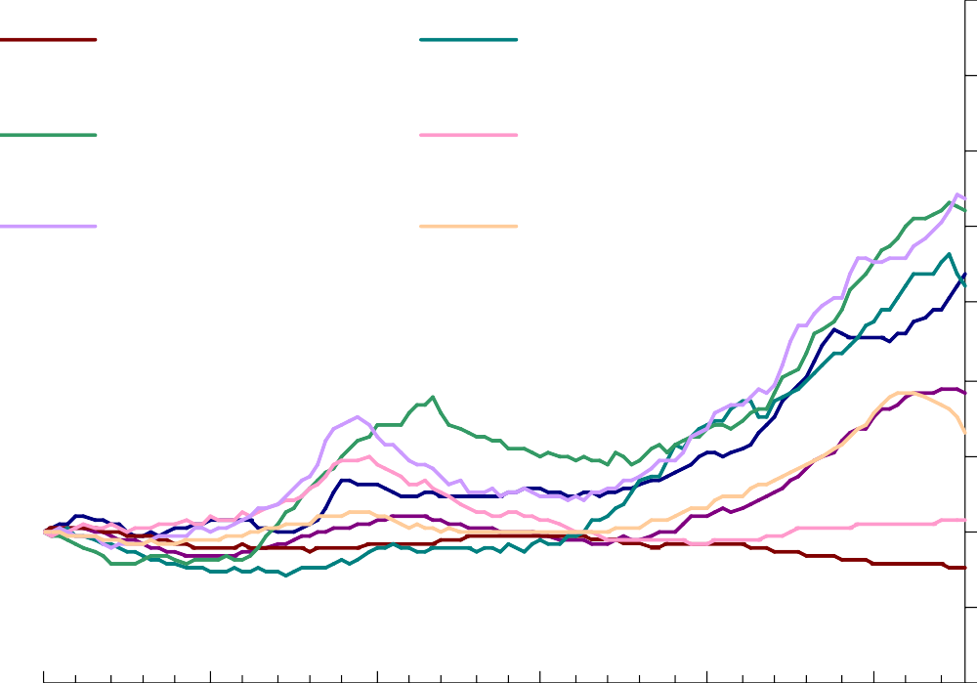

Germany

Ireland

Spain

Switzerland

United Kingdom

United States

400

350

300

250

200

150

100

50

0

1980 1985 1990 1995 2000 2005

Source: Bank for International Settlement

* 1. **The Great Moderation**

Output and inflation volatility in the G5

UK: K US: S Japan: J Germany: G France: F

Standard deviation of inflation

|  |  |  |  |  |  |
| --- | --- | --- | --- | --- | --- |
| 6 |  |  |  |  | *K* |
| 5 | *1970-92* |  |  |  | *J* |
| 4 |  | *F* |  |  |  |
| 3 |  |  |  |  | *S* |
| 2  1  0 | **1993-2007**  **K** | **S G** | **J** | *G* |  |

**F**

#### 0 1 2 3

Standard deviation of output growth

* 1. **The Great Moderation and risk perceptions** Implied volatilities from options – standardised to zero mean and unit variance

4

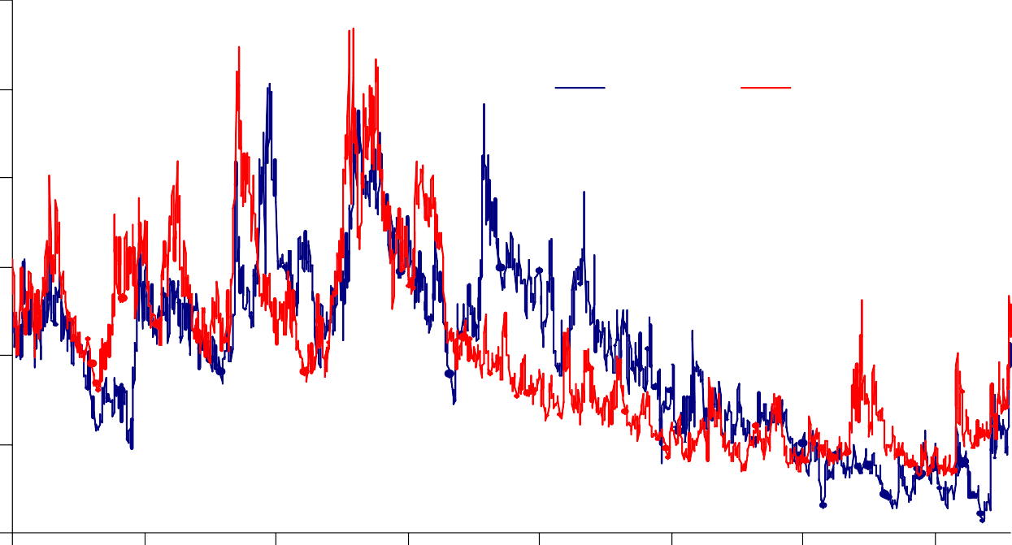

MOVE

VIX

3

2

1

0

-1

-2

2000 2001 2002 2003 2004 2005 2006 2007

* 1. **Overly Loose Monetary Policy?**

Deviation of policy rates from Taylor rule

### 5 Percentage points 4

Euroarea UK

US

3

2

1

0

-1

-2

-3

-4

-5

2000 2001 2002 2003 2004 2005 2006 2007 2008 2009

Source: OECD

* 1. **Global imbalances**

Current accounts (% of GDP, 5-year rolling average)

UK US

Japan Germany China

Percent of GDP

10

8

6

4

2

0

-2

-4

-6

-8

1950 1960 1970 1980 1990 2000

Source: IMF and national sources

* 1. **Long-term real interest rates**

Real 8.5 year government forward rates

Per cent

6

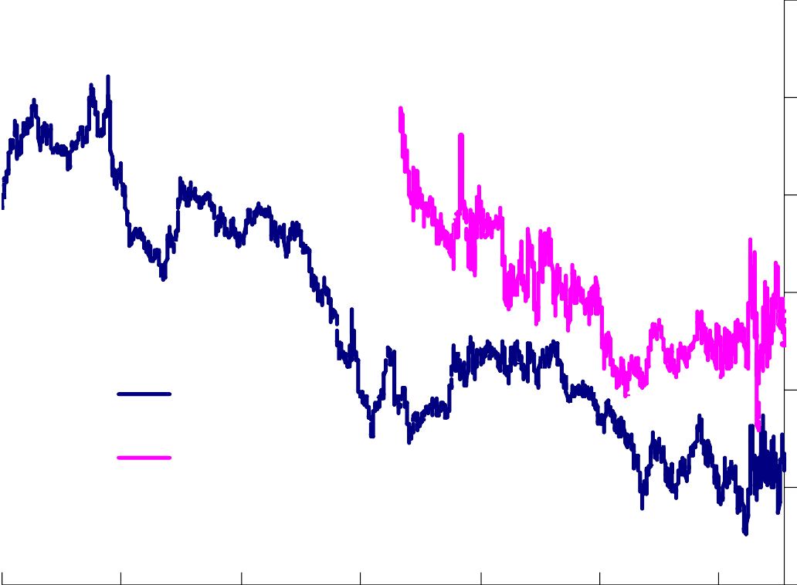

UK

US

5

4

3

2

1

0

1990 1993 1996 1999 2002 2005 2008

* 1. **Real house prices & current accounts**

10



Spain

United Kingdom New Zealand

Australia

France

Ireland

Sweden Belgium

Norway

Canada

United States

Italy

Finland

Switzerland

Germany

Japan

Percentage growth in real house prices (2000 Q1 - 2007 Q4)

5

0

-5

-10 -5 0 5 10 15 20

Current account/GDP (average 2000 Q1-2007 Q4)

RK = (1+λ)RL – λRD

# Defaults on US sub-prime mortgages

## Default rate by cohort of origination

### Per cent

24%

2001

2002

2003

2004

2005

2006

2007

22%

20%

18%

16%

14%

12%

10%

8%

6%

4%

2%

0%

3 6 9 12 15 18 21 24 27 30 33 36

Months After Issuance

So urce: Moo dy's Inve s to rs Service.

* + 1. Adjus table ra te mo rtgages , relative to o riginal balance.
  1. **Pay-offs & prices on CDO tranches**

Price (per cent of par)

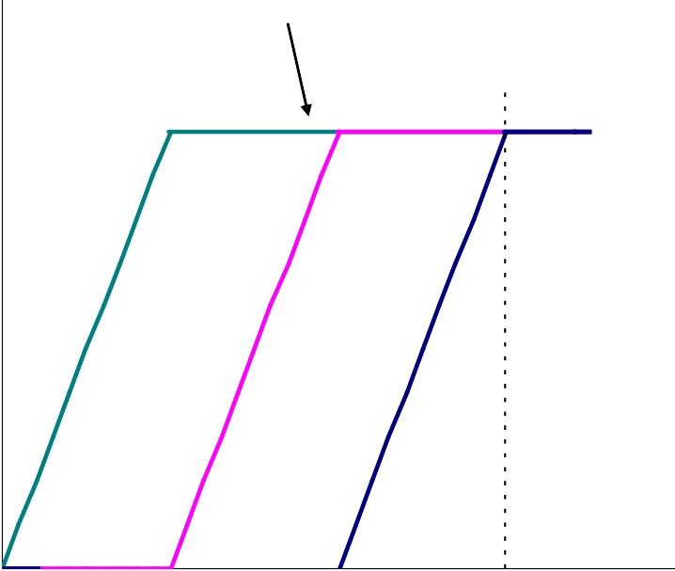

Tranche

payoff

Maximum payoff

*S 0*

120

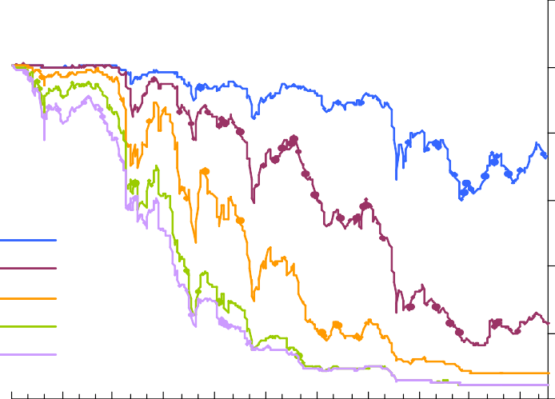

AAA AA A BBB BBB-

100

80

60

40

20

*K 3 K 2 K !*

0

Jan. Apr. Jul. Oct. Jan. Apr. Jul. Oct. Jan. Apr. Jul.

*S*

*T* 2007 08 09

Source: JP Morgan Chase & Co.

1. Each index references 20 home equity loan (HEL) ABS of indicated rating issued in 2005 H2. Sub-prime mortgages form the vast majority of the collateral backing HEL ABS.

# CDS spreads for major financial institutions

Basis points

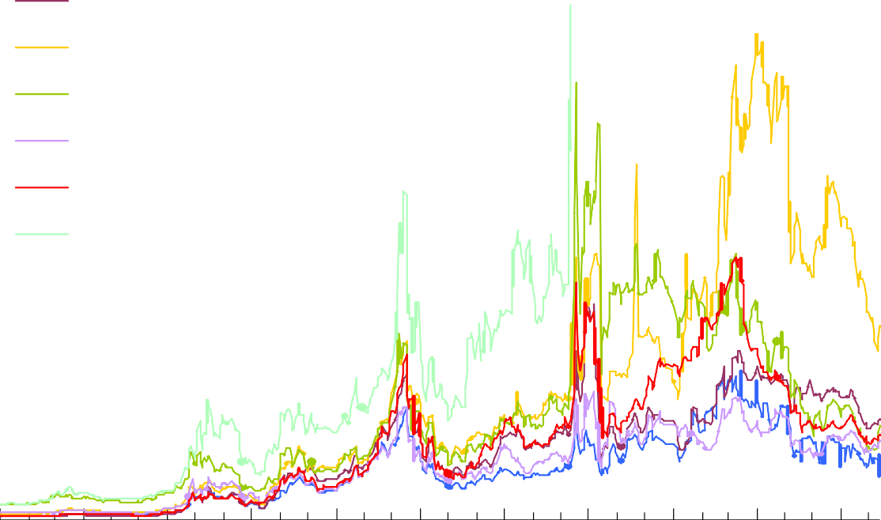

HSBC RBS

Citigroup Goldman Sachs Deutsche Bank UBS

Lehman Brothers

800

700

600

500

400

300

200

100

0

Jan. Apr. Jul. Oct. Jan. Apr. Jul. Oct. Jan. Apr. Jul.

2007 08 09

Source: Markit.

(a) Five-year senior CDS premia.

* 1. **The Great Panic: the flight to quality**

Spread between US Treasuries and Eurodollar rates

Percentage points Per cent

7 7

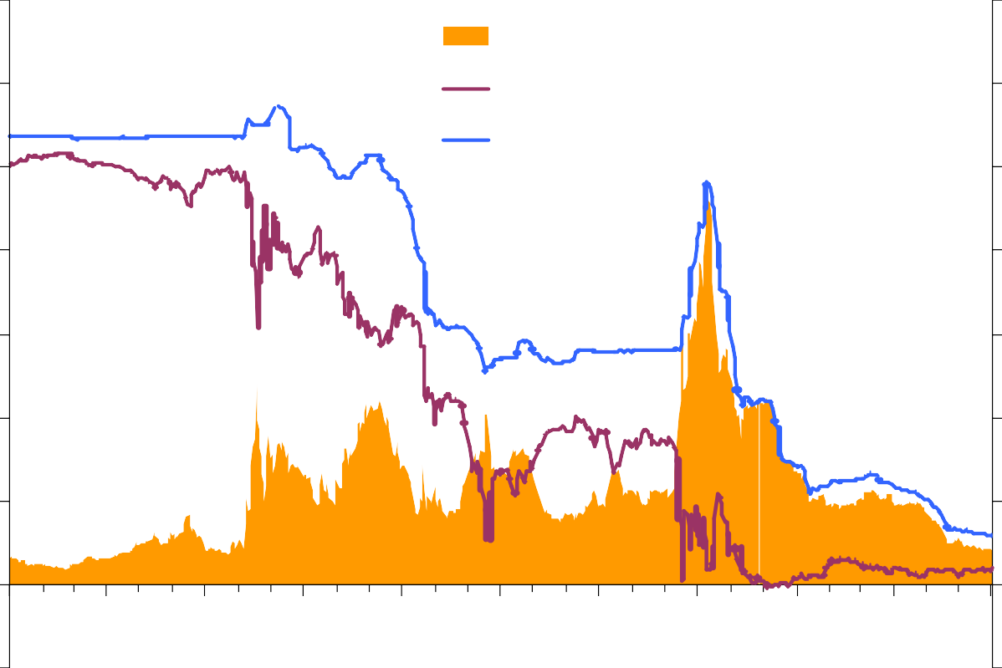

TED spread (lhs)

3-month T-bill yield (rhs)

3-month eurodollar rate (rhs)

6 6

5 5

4 4

3 3

2 2

1 1

+0 0+

-1 1 -

Jan. Apr. Jul. Oct. Jan. Apr. Jul. Oct. Jan. Apr. Jul.

2007 08 09

Source: Bloomberg

* 1. **Expected losses get bigger & bigger…**

Financial sector writedowns on US originated assets

##### $bn 3,000

2,500

2,000

1,500

1,000

500

Apr-08

Oct-08

Jan-09

0

##### Apr-09

So urce: IM F, *Glo bal Financ ial S tability R epo rt, Wo rld Eco no m ic Outlo o k* , vario us iss ues . Es timates o f po tentia l writedo wns fo r 2007-2010 o n US o riginated as s ets as repo rted in the GFSR and GFSR

quarterly updates .

# The Great Contraction

Percentage changes on a year

12

World real GDP grow th

World trade volume grow th

IMF July 2009 WEO update

forecast for 2009 and 2010

8

4

0

-4

-8

1970 1975 1980 1985 1990 1995 2000 2005

Source: IMF World Economic Outlook

-12

2010

1. **UK financial network in 2007**

Gross bilateral exposures

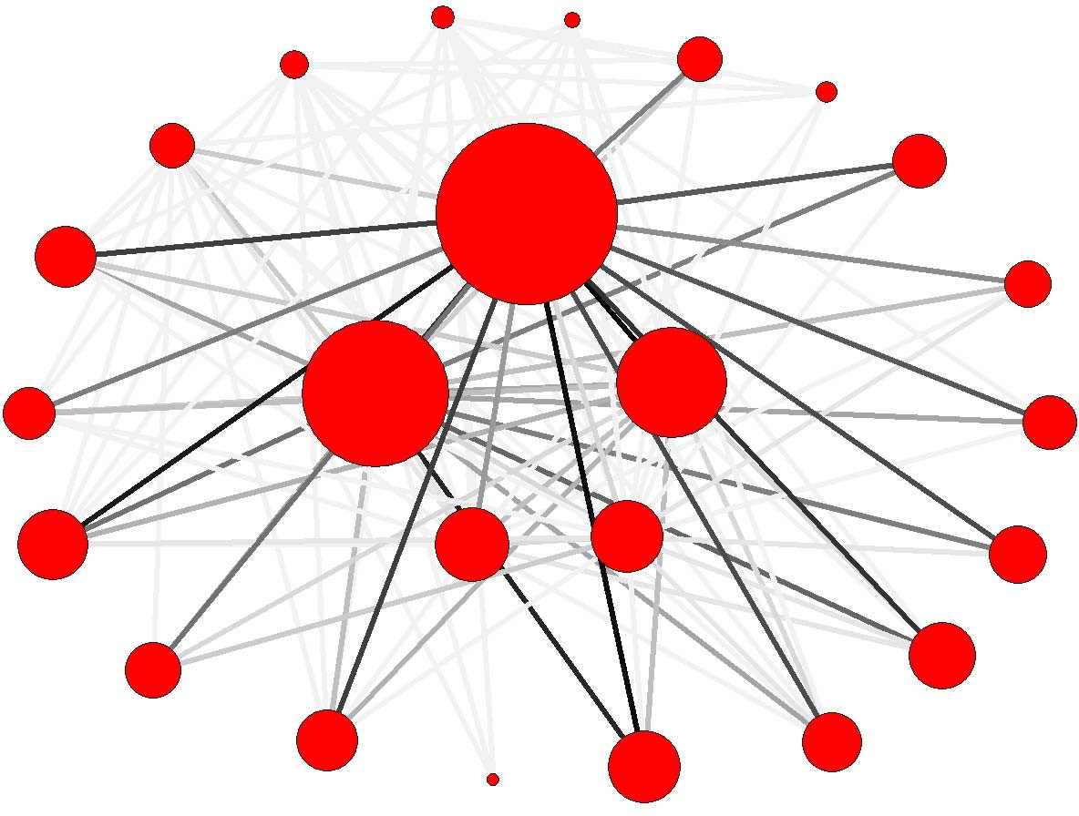

1. **International financial network in 2005**

External assets + external liabilities

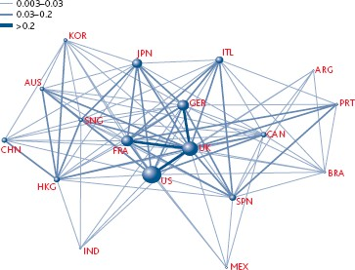

Source: BIS, IMF, OECD, UNCTAD and Kubelec and Sa (2009)

1. **Total output loss in slowdowns & recessions**

Medians, % GDP

0

-1

-2

-3

-4

-5

Slowdowns Recessions

Preceded by financial stress

Not preceded by financial stress

Preceded by financial stress

Not preceded by financial stress

Source: IMF WEO October 2008

1. **Central bank balance sheets**

Central Bank total liabilities (index: Aug. 2007 = 100)

400



350

300

250

200

150

100

50

0

Aug-07 Dec-07 Apr-08 Aug-08 Dec-08 Apr-09 Aug-09

Federal Reserve ECB Bank of England

Source: Federal Reserve, ECB and Bank of England

**The Great Moderation, the Great Panic and the Great Contraction**

THE END



[**www.bankofengland.co.uk**](http://www.bankofengland.co.uk/)